**Public Lecture**

**Mainstreaming Distance Education**

**Opportunities and Challenges**

In this session I will take a critical look at the **key attributes of open, flexible and distance learning** and review its **opportunities and challenges** for contemporary society and systems, and **issues to do with accreditation and credit** **transfer** including:

* Notions of the “separation” of the teacher and the learner from the perspectives of *time* and *space*;
* Influence and role of an educational organization including different types of organizational models for transfer of credit;
* The full range of technologies that are used to connect and re-engage the teacher and the learner in distance education;
* The full range of technologies and opportunities employed in distance education to support all forms communication for learning, teaching and assessment among learners and learners and teachers in distance education;
* The role of face-to-face contact in distance education including the notions of blended and flexible learning, including how much, when and where in order to retain the integrity of DE as a viable alternative form of educational provision; and
* The progressive nature of distance education which is characterised by the disaggregation of roles and functions in it, unlike the aggregated form that is typical of conventional forms of education.

# Presenter

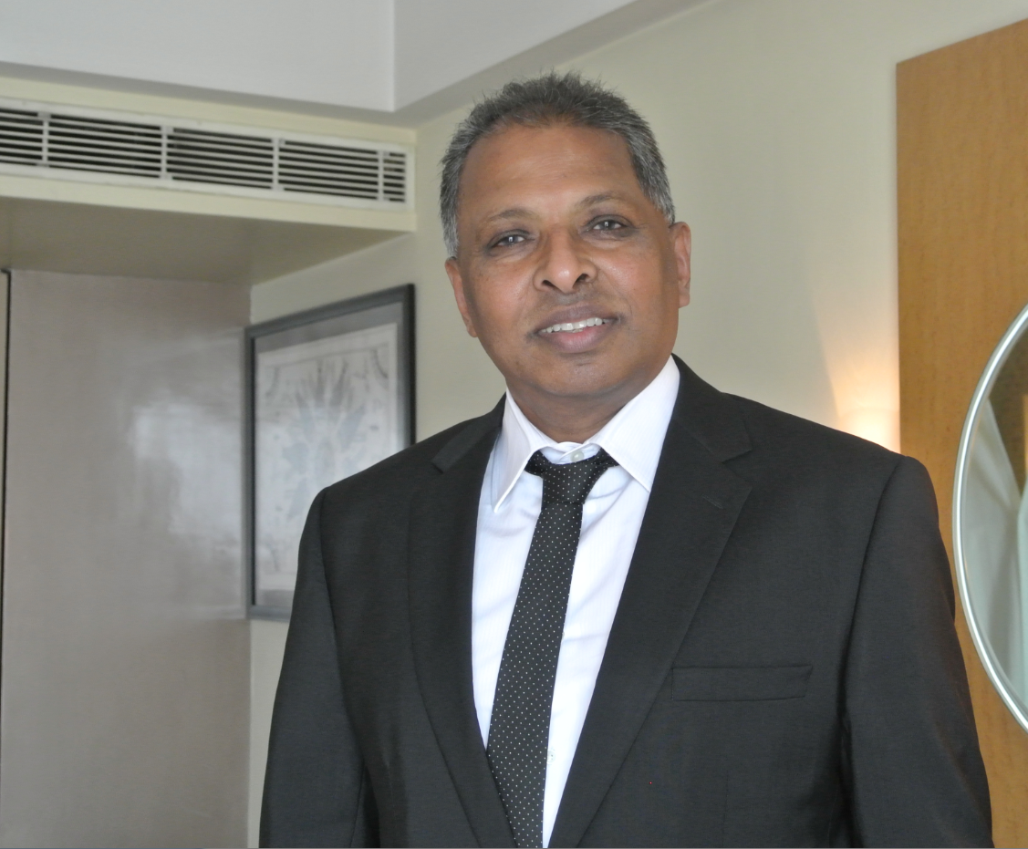

**Som Naidu, PhD; D. Litt. (Honoris Causa)**

Monash University, Melbourne, Australia

Email: [somaiya.naidu@monash.edu.au](mailto:somaiya.naidu@monash.edu.au); sommnaidu@gmail.com.

**Principal Associate:** *Technology, Education and Design Associates*

**President:** *Open and Distance Learning Association of Australia* (http://www.odlaa.org/)

**Executive Editor:** *Distance Education* [http://www.tandf.co.uk/journals/CDIE].

**Assistant Editor:** *Interactive Learning Environments* [<http://www.tandf.co.uk/journals/NILE>]

**Routledge Education Arena Panel:** <http://www.educationarena.com/expertPanel/panel2/>

Email: [sommnaidu@gmail.com](mailto:sommnaidu@gmail.com); somaiya.naidu@monash.edu.au

Dr. Naidu is currently an Affiliate Associate Professor at *Monash University*. He has previously served as *Associate Professor (Learning Transformations)* at Swinburne University of Technology in Melbourne, *Associate Professor and Director of Teaching and Learning Quality Enhancement and Evaluation of Learning and Teaching* at Charles Sturt University, NSW Australia, and *Associate Professor of Educational Technology and Multimedia Education* at the University of Melbourne.

Dr. Naidu possesses undergraduate qualifications in *Education* from the University of Waikato in New Zealand and graduate qualifications in *Distance Education* and in *Educational Technology* from Concordia University in Montreal, Canada. He has undertaken sabbaticals at *Northwestern University (USA)*, *Manchester Metropolitan University, and the University of London in the UK*. His publications in the areas of his expertise include several books, book chapters, and more than a hundred peer-reviewed journal articles and refereed conference papers.

Dr. Naidu is the current president of the *Open and Distance Learning Association of Australia*, executive editor of its journal *Distance Education*, and assistant editor of the journal *Interactive Learning Environments*. In May 2014 the Open University of Sri Lanka awarded Dr. Naidu a *D.Litt. (Honoris Causa),* in recognition of his extensive contribution to the field of *open, flexible, distance and e-learning* both regionally and internationally.